

Cloud Operations & Innovation (“CO+I”)
Pre-Market Feasibility Study of the Co-Location of
Trevi’s Waste (Residual) Heat Driven Forward Osmosis (FO)
Desalination Systems with Microsoft Data Centers Sites

CASE 2 (Draft report)

May 30th, 2025

Contents
Background 3
Why FO Loves Waste Heat 3
Waste Heat Utilization Scenario & Heat Pump Assumptions 6
Calculations of Coefficient of Performance (COP) for Heat Pumps as a Function of Surrounding Temperature & Assumptions 6
Case 2: Seawater Datacenter Site Selection 7
Case 2: Seawater Datacenter Assumptions 9
DC Site location Criteria 9
Designing the FO Plant 10
Levelized Cost of Water (LCOW) Analysis for FO and RO Scenarios 12
Results Summary: 13
Footprint and Uses 15
Potential Applications for FO Desalinated Seawater 15
Site Selection Justification 16
Key Advantages of Seawater Desalination with Forward Osmosis (FO) for Data Centers 19

Background
Trevi’s thermally driven Forward Osmosis (FO) technology utilizes low-grade waste heat for desalination. As part of a broader study for the client, Trevi will be evaluating the utilization of waste heat from Data Centers (DC) to determine the effectiveness and impact on the desalination of various water sources with forward osmosis and comparing the Levelized Cost of Water (LCOW) with that of traditional reverse osmosis (RO) systems. The 3 cases are:

- Case 1 – Inland Brackish: FO systems paired with data centers near brackish groundwater sources (<10,000 mg/L TDS), such as in New Mexico or West Texas.

- Case 2 – Coastal Seawater: FO systems treating ocean water (~35,000 mg/L TDS) near coastal data centers with access to fiber and seawater (e.g., San Diego, Corpus Christi).

- Case 3 – Industrial Produced Water: High-salinity FO deployments (>150,000 mg/L TDS) in oil and gas basins, where data centers can be co-located with upstream or midstream operations.

This report will evaluate Case 2 which are coastal sites using seawater as the source for FO desalination utilizing waste heat. It will explore how location, feedwater salinity, surrounding temperatures and co-location with data centers using 30 °C waste heat influences the quantity and quality of desalinated water, as well as the resulting LCOW compared to conventional RO systems. High-level engineering schematics, including mass balances and plant footprint estimates, are provided. A simplified techno-economic analysis (TEA) is also performed using average monthly ambient temperatures rather than hourly data.

The impact of transforming an otherwise wasted resource (low-grade heat) into a valuable one (clean water) for all the above 3 cases will be evaluated in the fourth phase of this study.
Trevi Systems has identified five U.S. coastal metros—San Diego, Corpus Christi, Miami, Virginia Beach, and Honolulu—as optimal starting points for evaluating the deployment of Forward Osmosis (FO) seawater desalination systems powered by residual data center waste heat. An explanation on the rationale selection of these cities will be highlighted later in this report.

Why FO Loves Waste Heat
Trevi Systems’ Forward Osmosis (FO) technology represents a paradigm shift in sustainable desalination—one that converts low-grade waste heat into a driver for water purification.
Data centers (DCs) present a compelling solution to provide waste heat to Trevi’s forward osmosis systems. They generate abundant waste heat—up to 1 GW—and are often located near impaired water sources that require desalination, as well as near population centers with growing water demands.

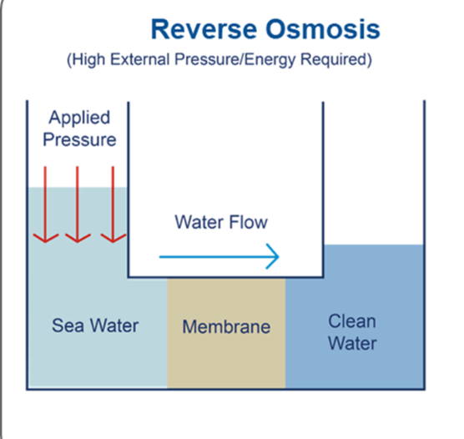
Unlike pressure-driven Reverse Osmosis (RO), FO is an osmotic process wherein water diffuses across a semi-permeable membrane from a low-solute concentration feed (e.g., seawater or brackish water) into a concentrated draw solution. This process occurs spontaneously, requiring no high-pressure pumps, thus significantly reducing mechanical energy requirements, high external pressures and the membrane stress associated with RO as depicted below. The diagram below demonstrates that RO utilizes a high pressure to force dirty water against a membrane, which allows clean water through and retains brine on the other side of the membrane. Note that the pressure limitations of RO is up to 120 bar = 1740 psi.

Diagram of Reverse Osmosis process
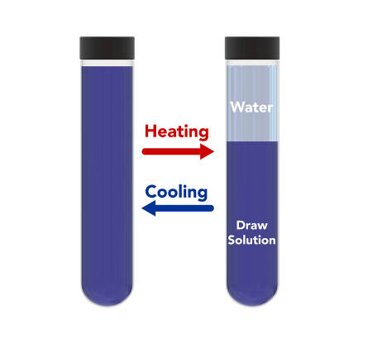
Trevi’s FO process on the other hand utilizes proprietary draw solutions (capable of up to 3600 psi ~ = 240 bar osmotic pressures) which is a homogenous liquid at lower temperatures (and therefore can exert osmotic pressure) and becomes immiscible with water at higher temperatures (65deg C to 95 deg C) as depicted below.

Diagram of Trevi’s Draw Solution at differing temperatures
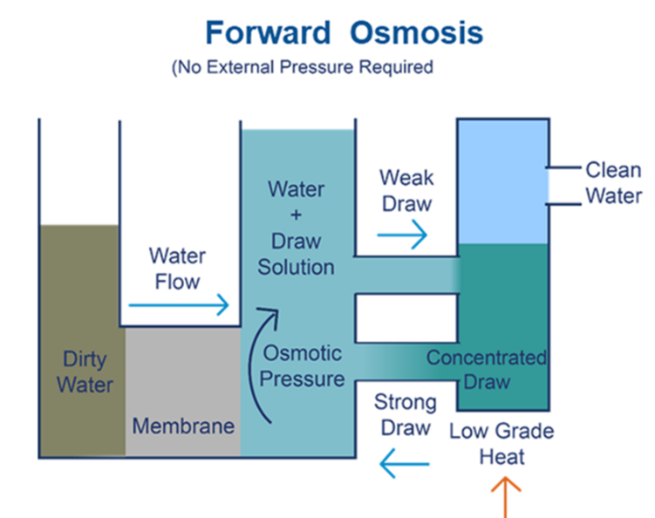
Trevi’s forward osmosis process utilizes the above draw solution in the FO diagram below by placing the draw solution on one side of a membrane, the draw solution (in its homogeneous phase at lower temperatures) pulls clean water through the membrane by the natural process of osmosis leaving dirty water / brine on the other side of the membrane.

Diagram of Forward Osmosis process
The draw solution then becomes dilute with water and the water is then separated from the draw by heating up the draw solution which causes it to then become immiscible with water, dropping to the bottom of the system, thus allowing for the clean water to be decanted off and concentrated draw solution to be recycled back into the FO system to continue the desalination process. As expected, this process does not happen under any external pressures and stainless-steel equipment for the high pressures are not required.
Trevi has more than 300 draw solutions in our draw solution library, allowing us to treat a variety of wastewaters and also allowing our FO process to concentrate brine to beyond what a standard RO system can do. Due to our draw solution’s thermal separation process at 70 deg C to 95 deg C, which can be manipulated, Trevi’s draw solution thrives on the availability of consistent low grade waste heat which can continually drive the draw solution process. In addition, Trevi’s draw solutions deployed are certified food grade safe and biodegradable which makes is an easy and safe option for deployment. Compared to standard reverse osmosis, Trevi’s FO process utilizes one third the electrical power of that of a RO system but does additionally require some form of waste heat. The draw regeneration stage is thermally driven, and therefore ideally suited to integration with existing sources of waste heat such as those produced by data centers, power plants, steel manufacturing, chemical processing , cement and/or geothermal plants.

Waste Heat Utilization Scenario & Heat Pump Assumptions
As in Case 1, this analysis considers a nominal 1 MW thermal cooling load from a data center, with waste heat rejected at either 30 °C or 45 °C and a return temperature fixed at 18 °C and 30 °C respectively in a closed-loop cooling configuration, as shown in Figure 1. Trevi’s FO system operates at 85 °C, requiring a temperature lift of up to 50 °C (from 30 °C), or slightly less in the 45 °C case. Both are considered high-lift applications and require appropriately designed heat pumps. A detailed evaluation of heat pumps was conducted in the Case 1 report and the our calculations for the nominal case of 30C heat, 18C return for a rotational heat pump with a supplier measured Coefficient of Performance (COP) of 3.5 at these conditions and the reject heat at 79C for Trevi’s FO system resulted in a COP of 3.5 as our basis.
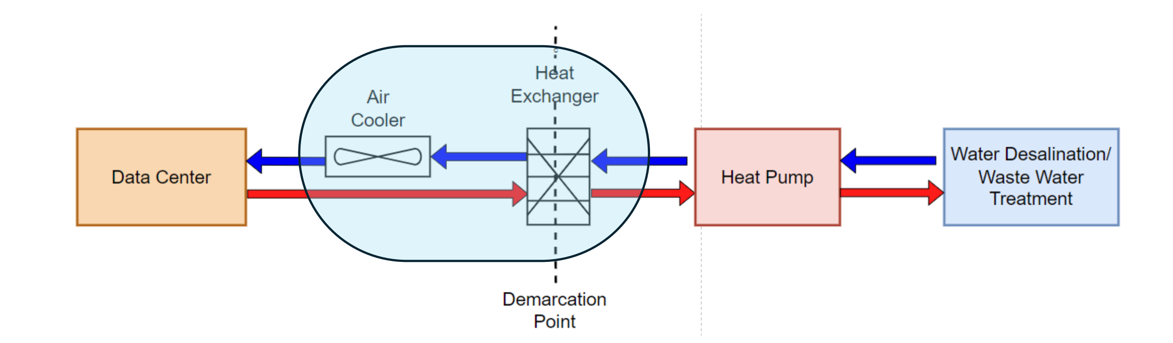
Fig. 1 Trevi’s FO System Integrated into the DC cooling system with Heat Pump

Calculations of Coefficient of Performance (COP) for Heat Pumps as a Function of Surrounding Temperature & Assumptions
In Case 1 (inland brackish ground water source), we compared running our FO plant using waste heat from the datacenter against running it against ambient air to see the benefits of the constant datacenter heat source. For Case 2 (seawater source), we ran the FO plant using the seawater as source heat to assess the benefits of using datacenter heat instead of seawater as heat source. A more meaningful approach and one which Trevi favors is to use solar heat or powerplant heat for this coastal application, as the ocean temperatures overlap with the low temperature heat from the datacenter, and their seasonal variations are much smaller than inland ambient variations, minimizing the benefits of the datacenter waste heat supply.
As part of the calculations for the LCOW for FO without waste heat, the formula is as such:
=Annualized (Electricity Cost + Thermal costs (with HP & sea cooling & no WH)+ FO CAPEX+FO OPEX+ Heat Pump CAPEX)/1000
COP for Seawater is required to calculate the Thermal costs (with a HP utilizing sea cooling and no WH) by using the average monthly seawater temperatures of each city. The monthly average seawater temperatures assumed for each city and the COP calculation results are shown in Appendix 1.
It is important to note that the COP for the HP for the DC which gives out waste heat at 30 deg C = 3.5 and was used to calculate the LCOW for FO with waste heat at 30 deg C, the corresponding formula is as such:
=Annualized (Electricity Cost + Thermal costs (with HP & WH @ 30 deg C)+ FO CAPEX+FO OPEX+ Heat Pump CAPEX)/1000
For the COP for the HP for the DC which gives out waste heat at 45 deg C, we adjusted the COP using the ideal carnot efficiency for 30C and the ideal carnot efficiency for 45C and then increased the actual manufacturers carnot efficiency at the first case, yielding a COP of 4.8. This COP was used to calculate the LCOW for FO with waste heat at 45 deg C, the corresponding formula is as such:
=Annualized (Electricity Cost + Thermal costs (with HP & WH @ 45 deg C)+ FO CAPEX+FO OPEX+ Heat Pump CAPEX)/1000

Case 2: Seawater Datacenter Site Selection
The following 5 US cities San Diego, Miami, Corpus Christi, Virginia Beach and Honolulu were selected as sites for Case 2 evaluations. Apart from these cities having access to a coastline to pull in seawater, these cities have notable infrastructure and other aspects potentially making them suitable locations for data centers.
San Diego
San Diego offers a dynamic opportunity as a Pacific-facing coastal data center hub, providing direct access to transpacific subsea cables, a thriving local tech ecosystem, and a mild climate that supports energy-efficient operations. It’s positioned to serve growing demand for international connectivity, low-latency services, and sustainable, West Coast digital infrastructure.
Miami
Miami stands as a vital coastal data center gateway for North-South digital traffic, connecting the U.S. with Latin America and the Caribbean through one of the nation’s densest subsea cable networks. Its position as a financial, business, and tech hub ensures steady demand, while resilient, hurricane-ready facilities maintain high uptime for international networks.

Corpus Christi
Corpus Christi has the potential to become a next-generation, renewable-powered coastal data center hub, serving as a key redundancy and disaster recovery site for Gulf Coast networks, a future subsea cable gateway to Latin America and the Caribbean, and a cost-effective, clean-energy-powered location leveraging South Texas’ growing wind and solar resources.
Virginia Beach
Virginia Beach is quickly emerging as a premier transatlantic data center hub, anchored by high-capacity subsea cables connecting the U.S. with Europe, South America, and Africa. Its proximity to Northern Virginia’s hyperscale corridor and access to renewable offshore wind make it a resilient, globally connected coastal infrastructure destination.
Honolulu
Honolulu serves as a strategic transpacific digital gateway, linking the U.S. mainland with Asia, Australia, and Pacific island nations through critical subsea cables. Its geographic isolation enhances network redundancy and disaster recovery, while Hawaii’s expanding renewable energy capacity supports clean-powered, climate-resilient coastal data infrastructure
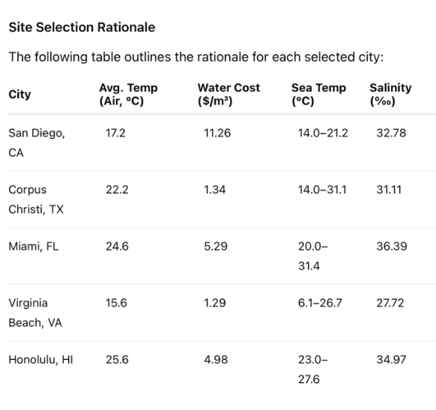
Site data for each city is as follows:

Case 2: Seawater Datacenter Assumptions
For our Case 2, Trevi will assume an incoming salinity of 35,000 mg/L total dissolved solids (TDS) and a final brine concentration of 100,000 mg/L which assumes ocean discharge which is the most common and least expensive way of disposing of seawater desalination brine. 1MW of cooling based on the energy requirement for Trevi’s thermal FO desalination plant is projected to produce 1000m³/day of desalted water for 35,000 mg/L of TDS.
Trevi’s FO system can use its standard draw solution which is capable of achieving the osmotic pressure sufficient to achieve the required brine concentration. Thermal and electrical power will remain largely constant over this input salinity range as shown in Table 5 below. The Plant is designed to produce potable water, making it suitable for all applications (except unique industrial applications such as boiler feed makeup, semiconductor etc). These can be accommodated, the water for potable use is re-mineralized. Permeate TDS will be less than 300mg/l as shown in Table 5. Production rate will remain constant independent of input salinity over the input salinity range of 26,000 to 37,000 mg/L due to the high osmotic pressure of Trevi’s draw solutions negate the impact of incoming TDS of feed water.

DC Site location Criteria
The DC, heat pump, FO plant and the seawater source should all be co-located together not more than 500-1000 yards apart. Coastal data centers must be located near the sea to access seawater for efficient cooling, but equally critical is the co-location of a forward osmosis (FO) seawater desalination plant and the heat pump directly adjacent to or within the data center campus. This close physical integration is essential because the FO desalination plant and heat pump utilizes low grade waste heat (in the form of 30 deg C or 45 deg C water) supplied by the DC to the forward osmosis desalination plant to drive draw solution regeneration for the production of clean portable water which could be used for different applications. The forward osmosis desalination plant could also be used to supply the DC facility with a sustainable, reliable source of clean water needed for cooling and operations without relying on limited municipal freshwater resources. Co-locating the DC, heat pump, FO plant and the seawater source minimizes water transport energy, reduces infrastructure complexity, and enables a closed-loop system where seawater is efficiently converted into high-quality process water on-site and allows for easy access to discharge the brine from the FO desalination plant as well. This proximity ensures optimized operational efficiency, lowers environmental impact, and supports the data center’s long-term sustainability in water-constrained coastal regions.

Designing the FO Plant
Based on the parameters and assumptions described above for Case 2, and using Trevi’s 8 FO systems built to date, a 1000 m3/day FO seawater desalination plant was designed with a CAPEX of $1,651,721 and annual OPEX of $130,636 for chemicals and consumables (excluding energy which is calculated separately). This differs slightly than the CAPEX and annual OPEX of $1,661,668 and $115,590 for the brackish FO desalination system mainly because of the pre-treatment and post treatment requirements of seawater versus brackish water.
Brackish water typically contains lower salinity and fewer suspended solids compared to seawater. Pre-treatment focuses on removing fine particulates, iron, manganese, and organic matter to prevent membrane fouling and scaling and a simple cartridge filter would suffice. The milder nature of brackish water generally allows for simpler, less intensive pre-treatment compared to seawater.
Seawater, on the other hand, has higher salinity, a greater concentration of suspended solids, microorganisms, and organic compounds, and often more complex fouling agents like algae and silt. Therefore, seawater pre-treatment is more rigorous and multi-staged. Our pretreatment step included a multimedia filtration – ultrafiltration and more chemical dosing for scaling, corrosion inhibition, and biofouling control. The goal is to ensure the removal of a wide range of contaminants and protect membranes from more aggressive fouling, ensuring long-term, reliable operation in harsh marine environments.
In simpler terms, brackish water is typically cleaner, has lower salinity, less oxygen (so less microbial matter) and thus results in a slightly lower CAPEX and OPEX for a plant of similar size compared to a seawater FO desalination plant.
The components of the 1000 m3/day FO seawater desalination system for CAPEX and OPEX are extremely similar to that of the 1000 m3/day brackish seawater desalination system with FO membranes making up the majority of the FO costing. It will also be the component that, as volume increases, matures quickest in its cost reduction path, allowing future FO systems to be 10-20% lower in cost than what is used in this TEA.
A detailed PFD with mass balances was also developed. Please see the next page for a brief overview of it. A more detailed diagram can be found in the corresponding EXCEL sheet along with mass balances sent separately.

PFD & Mass Balance
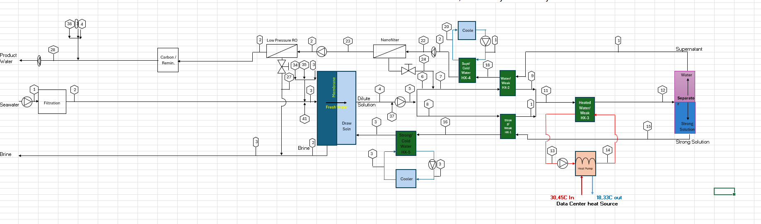
PFD for 1000 m3/day Seawater FO Desalination plant

Mass Balances for 1000 m3/day Seawater Desalination plant
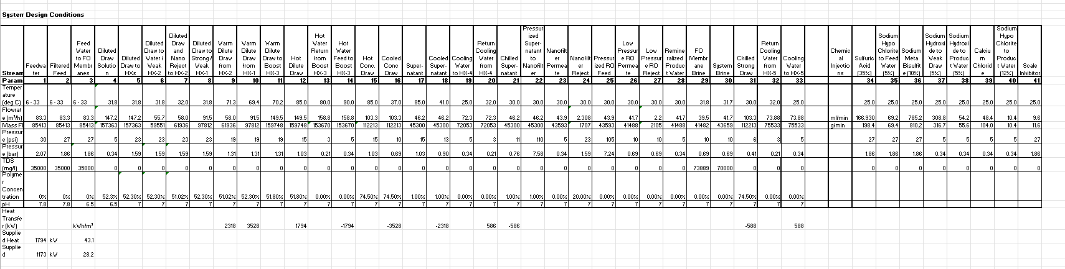

Levelized Cost of Water (LCOW) Analysis for FO and RO Scenarios
This section presents the Levelized Cost of Water (LCOW) assumptions for four distinct system configurations, including FO with and without data center (DC) waste heat integration, and a comparative RO scenario. All systems are modeled to deliver 1000 m³/day of treated water which is what 1 MW of heat can achieve with a FO desalination system for seawater.
Scenarios Evaluated:
- FO Only – Seawater-Cooled with Heat Pump:
A 1000 m³/day Forward Osmosis (FO) plant operating independently on the coast, without access to data center waste heat. The system uses seawater cooling and a heat pump to manage thermal and cooling requirements.
- FO + DC Waste Heat (30°C Inlet & 18°C Outlet):
An FO plant utilizing 30°C waste heat water from a data center, feeding Trevi’s heat pump, and producing 18°C outlet water with the heat pump. The cooled water will be recirculated to the data center for reuse in cooling using a heat exchanger as shown in Fig 1 above.
- FO + DC Waste Heat (45°C Inlet & 33°C Outlet ):
Similar to Scenario 2, but with higher-quality waste heat at 45°C. Trevi’s heat pump could cool the stream to 33°C as before.
- Benchmark RO System:
A 1000 m³/day Reverse Osmosis (RO) plant powered entirely by electricity, designed to achieve the same water treatment performance as the FO systems for comparison purposes.
Table 1 summarizes the key techno-economic input variables used in the LCOW analysis for each scenario.
Temperature lift of DC heat with FO  *Note: Lift is the average temperature from the cold side to the hot side. Thus for 30C, the average cold side = 24C and for 45C, the average cold side = 39. The lift on the hot side is an average of 79 (=(85C + 73C)/2) & therefore the difference is 79-24 = 55 or 79-39 = 40 | 40-55ºC
COP for Seawater Cooling for FO plant (No waste heat from DCs for FO plant) | Dependent on monthly ambient surrounding seawater temperature – See Appendix 3
COP for Water Cooling for FO Plant (45% of Carnot & with waste heat from DCs for FO plant with 30 deg C in & 18 deg C out) | 3.5
COP for Water Cooling for FO Plant (45% of Carnot & with waste heat from DCs for FO plant with 45 deg C in & 33 deg C out) | 4.8
Electricity Cost | 0.08c/kWh
Heat Pump CAPEX | $500,000
Seawater feed salinity | 35000mg/l
Seawater brine discharge | 100,000mg/l
System recovery rate (FO and RO) | 64 %
FO thermal Energy | 35kWh/m³
FO Electrical Energy | 1.1kWh/m³
RO Electrical Energy | 5.7 kWh/m³
FO or RO system Availability | 98%
FO or RO Permeate Water Quality | <300mg/l
Table 1 TEA Input variables
Other assumptions and scenarios include:
- The DCs supplies waste heat to the Trevi supplied heat pump which lifts it to the required 85ºC for the FO plant draw solution separation/regeneration.
- Five coastal city locations in the US are evaluated. These sites are:
  - San Diego, CA
  - Miami, Florida
  - Corpus Christi, Texas
  - Virginia Beach, VA
  - Honolulu, HI
The average seawater monthly temperatures of these cities (Appendix 1) will be evaluated to see if they have an impact on the economics for the LCOW of FO as a standalone plant and compared with the LCOW of FO utilizing the waste heat from data centers
- The CAPEX for the RO system used is that of an ultra-high pressure RO system or an osmotically assisted RO system to achieve the same salinity (100,000 mg/L TDS brine) which FO can achieve at this site while still allowing for ocean brine discharge.

Results Summary:
Using Table 1 above, the various scenarios are calculated below for 5 different geographical locations and the results shown in Table 2 below. A demonstration of how the numbers for San Diego, CA was derived is shown in Appendix 2.
Table 2. TEA Analysis for Seawater desalination
What is immediately evident is that forward osmosis desalination with or without waste heat from the data centers is unable to compete with seawater reverse osmosis (SWRO) desalination on the simple comparison of price without taking into account other factors like cooling credits or carbon credits which the FO desalination system can bring to the table compared to RO.
One simple reason is that the cost of seawater reverse osmosis (SWRO) desalination has dropped significantly over the past 20–30 years, both in terms of capital expenses (CAPEX) and operational expenses (OPEX), largely driven by improvements in membrane technology, energy recovery systems, plant design, and economies of scale. It is hard for an emerging and innovative technology like FO to compete with SWRO.
In addition, where FO excels is traditionally at brine concentration due to the high osmotic pressures of our proprietary draw solution, Trevi’s FO is able to concentrate up brines to high TDS concentrations at lower costs compared other incumbent methods. However, due to the ocean discharge of limits of each state, Trevi’s FO was not able to push the limits of brine concentration for these seawater desalination plants and brine concentration was only up to 100,000 mg/L. Comparing this with Case 1 for brackish inland desalination where the brine was concentrated up to 150,000 mg/L, Trevi’s FO was competitive and cheaper than ultra-high pressure reverse osmosis which was needed to get up to such high brine concentrations.
Furthermore, the LCOW for FO with and without waste heat from the data centers did not differ that much implying that the waste heat did not have much of an impact on mitigating Trevi’s FO thermal consumption. This is due to the fact that the presence of an abundance of seawater is a consistent source of cooling and also had a moderating effect on surrounding temperatures air and seawater temperature which in turn affects how hard the heat pump has to work for all the different scenarios. In the case of all these coastal cities, there was just not much of a difference the waste heat brought to the table for FO energy.
On the flip side, if the amount of cooling credit and carbon savings was taken into account for a SWFO system versus a SWRO system, Trevi’s SWFO system could appear more attractive as an optional for desalination at the coast.

However, in a similar observation for Case 1, a slightly higher heat source enables better LCOW numbers. Possibly if there was a data center which could give us 65 deg C wastewater, Trevi’s SWFO could compete with SWRO and could be studied in Case 4. In addition, places with large fluctuations in surrounding air and sea temperatures would also make for a better case for SWFO as then, the consistent waste heat from the Data Centers would have more of an impact on our thermal regeneration. In places like the Arabian gulf where the salinities are higher and the seawater and ambient temperatures swing more vastly, Trevi’s SWFO could be competitive with SWRO.

Footprint and Uses
A 1,000m3/day seawater FO system is approximately 20% larger than an equivalent size RO system due to slightly more pre-treatment requirements, but the size discrepancy disappears as the plant size increases, as we will demonstrate in Case 4 of this report.
Datacenter Size – Thermal load | FO Plant Size  (m³/day) | FO Plant area - sq ft and (sq m)
1MW | 1000 | 1750

Potential Applications for FO Desalinated Seawater
Desalinated seawater produced by FO can be an increasingly vital water source for a range of sectors, particularly in coastal and water-stressed regions. Its most prominent application is in supplying municipal drinking water, providing reliable, high-quality potable water to communities in arid coastal areas, island nations, and regions with dwindling freshwater supplies. Beyond residential use, industries such as power generation, oil refining, semiconductor manufacturing, and chemical production depend on desalinated seawater for process and cooling water, benefiting from its purity and consistency. In agriculture, desalinated water supports the irrigation of high-value crops, controlled greenhouse environments, and recreational landscapes like golf courses, particularly in areas where traditional freshwater resources are scarce or unreliable.
Desalinated FO seawater can plays a growing role in modern infrastructure and environmental management. Coastal data centers could integrate desalinated FO water for cooling systems, reducing strain on municipal water supplies and enhancing operational resilience. It can be used in environmental restoration projects to support wetlands and estuarine ecosystems during droughts, and in disaster relief operations where clean water access is critical. As both climate risks and water demands rise, desalinated seawater continues to diversify in application, supporting public health, economic development, and environmental stewardship across a wide range of sectors.

Site Selection Justification
In this section, we expand more on why we selected the 5 cities for the study.
San Diego, California stands out as a highly strategic coastal location for data center development, offering direct access to multiple existing and expanding Pacific subsea cable systems that connect the U.S. with Asia, Australia, and Latin America. This positions the city as a critical gateway for international data traffic and low-latency content delivery across the Pacific Rim. San Diego’s proximity to a thriving tech, biotech, and aerospace industry cluster ensures strong regional demand for cloud, edge, and colocation services, while its mild, coastal marine climate reduces data center cooling costs and improves energy efficiency. Though land and power costs are higher than in inland markets, the city’s advanced infrastructure, reliable power grid, and strong seismic resilience standards offset those challenges. With California’s ambitious renewable energy goals, data centers in San Diego can also increasingly access clean power through state programs and private power purchase agreements. Furthermore, opportunities for public-private partnerships with the Port of San Diego, regional utilities, and technology consortiums can help drive future investments in subsea infrastructure, sustainable energy solutions, and advanced digital facilities. These factors position San Diego as a dynamic, future-ready coastal data center market, offering international connectivity, access to a robust local tech ecosystem, and the advantages of a Pacific-facing digital infrastructure hub.
Miami, Florida serves as one of the most strategically vital coastal locations for data center infrastructure in the United States, acting as the primary digital gateway between North America, Latin America, and the Caribbean. The city hosts numerous subsea cable landings, including the renowned NAP of the Americas, one of the largest and most connected carrier-neutral interconnection hubs in the world. This exceptional subsea connectivity makes Miami indispensable for international data routing, low-latency services, and content delivery to rapidly growing markets in Central and South America. While the region faces challenges from hurricanes and rising flood risks, the city has a proven track record of resilient infrastructure, with modern, storm-hardened data centers designed to meet stringent uptime and safety requirements. Miami’s position as a global financial and business hub also ensures strong regional demand for colocation, cloud, and enterprise data services. Additionally, access to Florida’s expanding renewable energy resources and investment incentives for infrastructure resilience further strengthen the case for data center growth. With opportunities to partner with regional utilities, subsea cable operators, and international telecom providers, Miami remains a dynamic, internationally connected coastal data center market, offering unparalleled access to Latin American markets, financial sector clients, and global digital infrastructure networks.
Miami, Florida serves as one of the most strategically vital coastal locations for data center infrastructure in the United States, acting as the primary digital gateway between North America, Latin America, and the Caribbean. The city hosts numerous subsea cable landings, including the renowned NAP of the Americas, one of the largest and most connected carrier-neutral interconnection hubs in the world. This exceptional subsea connectivity makes Miami indispensable for international data routing, low-latency services, and content delivery to rapidly growing markets in Central and South America. While the region faces challenges from hurricanes and rising flood risks, the city has a proven track record of resilient infrastructure, with modern, storm-hardened data centers designed to meet stringent uptime and safety requirements. Miami’s position as a global financial and business hub also ensures strong regional demand for colocation, cloud, and enterprise data services. Additionally, access to Florida’s expanding renewable energy resources and investment incentives for infrastructure resilience further strengthen the case for data center growth. With opportunities to partner with regional utilities, subsea cable operators, and international telecom providers, Miami remains a dynamic, internationally connected coastal data center market, offering unparalleled access to Latin American markets, financial sector clients, and global digital infrastructure networks.
Corpus Christi, Texas presents an untapped opportunity to emerge as a strategic coastal data center hub along the U.S. Gulf of Mexico. Its prime location offers the potential to develop new subsea cable landing points, strengthening digital connectivity between the U.S., Latin America, and the Caribbean while filling a critical infrastructure gap between Florida and Houston. The region is also rapidly becoming a leader in renewable energy, with expansive wind and solar resources providing a pathway for data centers to operate on 100% clean energy through long-term power purchase agreements. Unlike heavily urbanized coastal markets, Corpus Christi offers ample, affordable land and lower construction and operational costs, making it an attractive destination for hyperscale, colocation, and enterprise data center developments. The city’s robust industrial infrastructure—including reliable power grids, transportation, and logistics networks—further enhances its ability to support energy-intensive digital infrastructure. While natural disaster risks exist, recent investments in modern construction codes and flood mitigation systems create opportunities to develop state-of-the-art, storm-resilient facilities tailored to 21st-century climate challenges. Additionally, public-private partnerships with the Port of Corpus Christi, ERCOT, regional telecom providers, and economic development agencies could drive new investment in subsea connectivity, renewable energy, and resilient data center infrastructure, positioning Corpus Christi as a forward-looking, cost-effective, and climate-ready digital infrastructure hub for the Gulf Coast and beyond.
Virginia Beach, Virginia has rapidly emerged as one of the most important and strategically valuable coastal data center markets on the U.S. East Coast, driven by its role as a premier subsea cable landing hub for transatlantic data traffic. The city is home to several high-capacity subsea cable systems connecting the United States with Europe, South America, and Africa, including the landmark MAREA and BRUSA cables, positioning Virginia Beach as a critical point of international digital exchange. Its proximity to the massive Northern Virginia data center corridor — the world’s largest — enables seamless, low-latency interconnection between hyperscale data centers and transoceanic fiber routes. Virginia Beach offers favorable land availability and competitive development costs compared to more urbanized markets, along with access to renewable energy options through the growing offshore wind industry and regional clean energy programs. The city’s moderate Mid-Atlantic climate reduces cooling costs, while modern infrastructure and improved coastal resilience initiatives address flood and hurricane risks. As demand for global network diversity and transatlantic capacity continues to rise, Virginia Beach presents a future-ready, strategically connected coastal data center destination, offering both international connectivity and direct access to the most concentrated cloud infrastructure ecosystem in the world.
Honolulu, Hawaii occupies a uniquely strategic position as the primary transpacific digital gateway between the United States, Asia, Australia, and the broader Pacific region. The city hosts several critical subsea cable landing stations, making it a key interconnection point for international data traffic traversing the Pacific Ocean. Honolulu’s geographic isolation from the mainland U.S. is a strategic asset, providing essential network redundancy and disaster recovery capabilities for Pacific and Asia-facing digital infrastructure. The city’s mild, tropical climate and consistent trade winds offer naturally favorable conditions for energy-efficient data center cooling, while Hawaii’s ambitious renewable energy goals and expanding solar and wind generation capacity provide long-term potential for sustainable, clean-powered operations. Although the island faces risks from hurricanes, tsunamis, and volcanic activity, its advanced building codes and regulated, resilient infrastructure mitigate these challenges for mission-critical facilities. Honolulu’s role as both a regional business hub and an international data transit point ensures steady demand for edge computing, colocation, and international content delivery services. With opportunities for collaboration between state authorities, regional utilities, and global telecom providers, Honolulu stands as a vital, future-ready coastal data center hub for transpacific digital infrastructure and resilient global network connectivity.
Some other cities in the US for consideration could be Seattle, Washington and Portland, Maine. Surrounding Seattle, the Puget Sound has very year-round cold water, there is a strong infrastructure for hyperscale (existing cloud and fiber presence), there are major subsea cable landings and power availability . One downside could be the possibility of seismic activity.
Surrounding Portland, the cold North Atlantic provides consistent, year-round low water temperatures ideal for seawater cooling applications. The region has a growing infrastructure for edge and enterprise data centers, with proximity to major fiber routes connecting to Boston, New York, and transatlantic subsea cables. Portland also benefits from lower natural disaster risk, particularly a low frequency of hurricanes and no significant seismic activity. One potential downside is that while hyperscale infrastructure is developing, it’s not as mature as in larger metropolitan markets

Key Advantage of Seawater Desalination with Forward Osmosis (FO) for Data Centers
- Coupling with Solar Thermal Energy
In scenarios where electricity generation is an issue say from diesel or gas, typically on island infrastructures or desert arid regions where fuel has to be transported in, Trevi’s FO system thrives on solar thermal as our main FO desalination driver utilizing up to one third of electricity for reverse osmosis making it a more suitable desalination technology in such scenarios.

Appendix 1: Mean Monthly Seawater Temperatures for 5 cities and the Corresponding COP
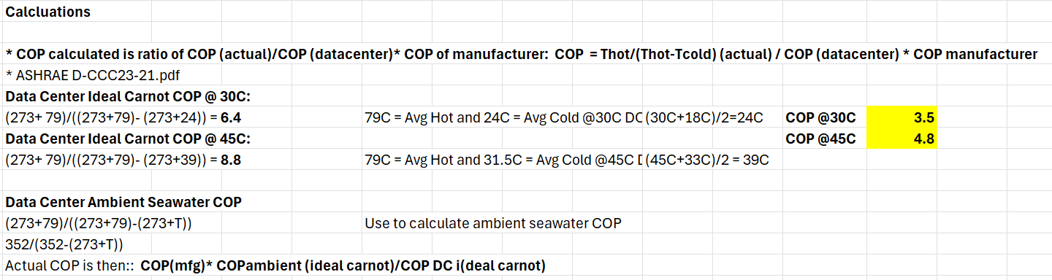
Appendix 2: Sample of LCOW Calculations for San Diego, CA
